

**Program: ESE 4009**

**INSTRUCTOR:** Prof**.** Mike Aleshams

# Group# 5

|  |  |  |
| --- | --- | --- |
| Student Name | Student ID | Signature* |
| ANKITKUMAR PATEL | C0747455 | Ankit |
| Gurvinder Singh | C0748418 | Gurvinder |
| Krutika Fanse | C0749076 | Krutika |

*\*By signing above you attest that you have contributed to this submission and confirm that all work you have contributed to this submission is your own work. Any suspicion of copying or plagiarism in this work will result in an investigation of Academic Misconduct and may result in a “0” on the work, an “F” in the course, or possibly more severe penalties.*

**Final Draft**

**Project Title:**

IoT based smart weigh scale and tank monitor

**Description of the latest similar system:**

**Flame King Smart Propane Tank Scale**​

Flame King smart propane tank scale is designed to measure 20,30 and 40lb propane tanks. Data measured by scale is feed to mobile app using Bluetooth connectivity. As per manufacturer scale need 2xAA batteries to operate. Below are some features of this scale.

**Features:-** ​

* Wireless Propane Gauge.​
* Track Propane Level from Your Phone.​
* compatible with 20, 30, and 40lb cylinders.​
* Bluetooth connectivity with mobile.​
* Easy to use free Android App.​
* Operated by 2x AA- batteries.​

**Limitations of the latest similar system:**

* **Resolution**:- Propane scale is compatible with 20, 30 and 40lb propane cylinders. We cannot use with custom weights​.

​

* **Compatibility**:- There is no zeroing function or a way to adjust for added weight.​

​

* **Connectivity**:- Only Bluetooth connectivity – so monitoring range will be an issue.​
* **Safety:-**There is no gas detector sensor. If there is any gas leakage there is no way to notification to user.​

​

* **Scalability:-**Can not cascade more than one scale with single app. It will be meaningful if we can monitor more than one scale with single App.​

**Solution : Integrating IoT connectivity with Gas-Leakage sensor**

* **Block Diagram**

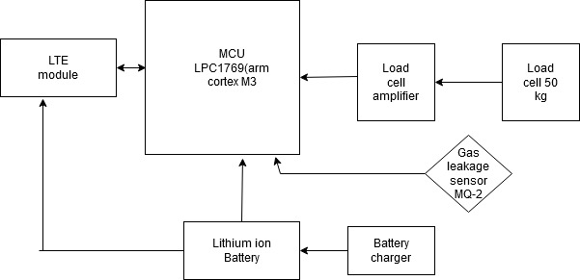

* **Features**

Load cell (100Kg) :- to measure weigh.

Load cell Amplifier:- We used SparkFun Qwiic Scale – NAU7802 board , which is used to amplify load cell signal and perform ADC operation and establish I2C communication with MCU.

Gas Sensor (MQ2):- We used MQ2 type sensor to detect hazardous gas leakage. It will be connected to MCU GPIO pin.

LTE module:- LTE module using I2C will be used to connect system with mobile App.

We will Use FreeRTOS ported on LPC1769 (Cortex-M3) board. Scheduling policy will be priority based preemptive. To reduce the power consumption we will use MCU and peripherals in low power mode. Semaphores and mutexes will be used for synchronization and queues for inter-task communication.

* **Hardware and Software Requirement**

**Hardware:-**

Load cell

Load cell amplifier

Gas sensor

NXP1769 Board

LTE module

Li-Ion battery

Battery charger

**Software:-**

FreeRTOS

LPCXpresso IDE

SEGGER-Systemview

Proteus

MIT App Inventor

**Milestones(Deliverables and Time Schedules)**

|  |  |  |  |
| --- | --- | --- | --- |
| TASKS | DATE OF START | DATE OF END | INCHARGE |
| HARDWARE REQUIREMENT | JUNE 12, 2020 | JUNE 21, 2020 | GURVINDER |
| COMPONENT TESTING AND CALIBARATION | JUNE 22, 2020 | JUNE 27, 2020 | GURVINDER |
| SCHMETIC DESIGINNG | JUNE 28, 2020 | JULY 06, 2020 | KRUTIKA |
| MOBILE APPLICATION DEVELOPMENT | JUNE 24, 2020 | JULY 15,2020 | KRUTIKA |
| INTERFACING LTE MODULE WITH LPC 1769 | JUNE 29, 2020 | JULY 10, 2020 | ANKIT |
| INTERFACING GAS SENSOR WITHLPC 1769 | JULY 11, 2020 | JULY 20, 2020 | KRUTIKA |
| INTERFACING LOAD CELL WITH LPC 1769 | JULY 21, 2020 | JULY 31, 2020 | ANKIT |
| FREERTOS CODE DEVELOPMENT | AUGUST 01,2020 | AUGUST 20, 2020 | ANKIT |
| PROTOTYPING | AUGUST 21, 2020 | AUGUST 24, 2020 | GURVINDER |
| FINAL DOCUMENTATION | AUGUST 25, 2020 | AUGUST 28, 2020 | GROUP |

* **References**

100Kg load cell

Updated on May 2016

* <https://www.robotshop.com/ca/en/type-s-load-cell-100-> kg.html?utm_source=google&utm_medium=surfaces&utm_campaign=surfaces_across_google_caen&gclid=EAIaIQobChMIodXSn_Lw6QIVj4jICh2f1woSEAQYBCABEgJ9pvD_BwE

SparkFun Qwiic Scale - NAU7802

Updated on July 2018

* https://www.sparkfun.com/products/15242

LTE module

Updated on October 2016

* <https://www.cisco.com/c/en/us/products/collateral/routers/4000-series-integrated-services-routers-isr/datasheet-C78-734341.html>

Updated on July 2016

* https://www.amazon.ca/Flame-King-Smart-Propane-Scale/dp/B07NRC2W4C

**Instructor’s Remarks**